

**CSE488: Big Data Analytics**

**[SPRING 2023]**

**Assignment**

**MapReduce to Calculate SUM**

**Submitted by:**

Student ID: 2019-3-60-046

Student Name: Mohsenul Kabir Mithun

**Creating a Hadoop project in Eclipse: (MapReduce used for** SumCalculator**)**

**🡪 MapReduce Program for** SumCalculator**:**

1. Open Eclipse IDE

2. Copy 'training' project and paste it on same place by name it "SumCalculator "

3. Expand SumCalculator 🡪 src 🡪 (default package)

4. Rename 4 of 3 java files are " SumCalculator.java", " SumReducer.java", " SumMapper.java" and replace the code that I provide bellow,

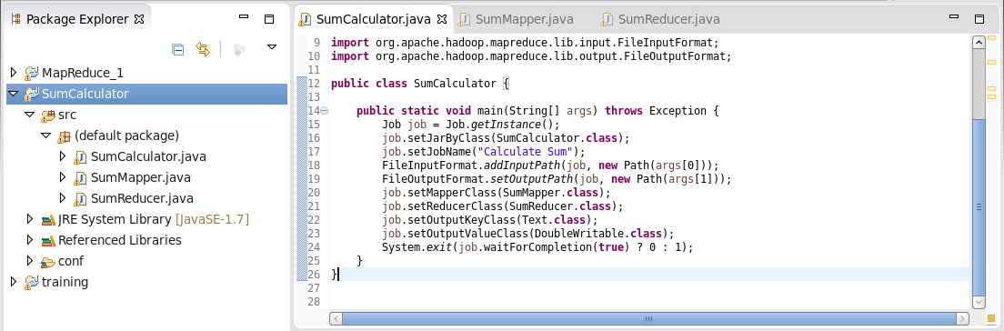

5. Right click on ' SumCalculator ' project 🡪  export 🡪 java 🡪 select jar 🡪 Next 🡪 give a jar file name as "Sum.jar" 🡪 Next 🡪 Next 🡪 Finish

6. Avoid if any error message occurs.

7. Go to http://quickstart.cloudera:8888/accounts/login/?next=/

8. Login by using Username: cloudera & Password: cloudera

9. Go to file browser that you see upper right side of the browser

10. Create new directory by click on New 🡪 Directory 🡪 provide name as ‘sum’ 🡪 go that directory create new file as file1.csv

11. Go to that file1.csv 🡪 click on 'edit file' option and add some text as coma separated. Then save it.

12. open CMD and write bellow command

hadoop jar sum.jar SumCalculator  /user/cloudera/sum/file1.txt  sumout

More generic way to explain:

🡪 hadoop jar <jar file> <main class> <input path> <output path>

13. To see output go to ‘Web Browser’ where you create a folder and add csv file. Here you also see another folder name as "sumout" In this folder you will find the output.

Thank you 🙂